**Table of Contents**

Introduction

Rationale for Adopting Social Media

Risks & Challenges

Methodology & Process Government Agencies Use

Measurement

Bibliography

Appendix

Survey Questionnaire

# Introduction

Social media is no longer in its infancy. Since Tom Truscott and Jim Ellis first started Usenet system in 1979, social media has gone through several rounds of evolution and has continued to offer public new and meaningful ways to communicate and engage in (Chapman, 2009). In recent years, along with the rapid growth of internet accessing speed and number of users, the vast explosion of smart mobile devices, social media can now be accessed at anytime, anywhere within a few clicks. With a smart phone penetration rate of 88% (Blackbox Research Pte Ltd, May 2012), social media has become an integral and important part of people’s lives in Singapore.

In recent years, Singapore government has started to make use of social media to interact with the general public. As a relatively new area to the government, there is no sufficient reference or study on social media used by the government. This report is to study the way government agencies handle social media, the processes they adopt as well as measurement on their success in using social media.

The study will first cover why government agencies need to adopt social media, what challenges they are facing, followed by the current status of social media usage. Based on the data collected, there will be discussion on how they handle social media. Last but not least, analysis on maturity and success level of using social media in government agencies will be provided.

# Rationale for Adopting Social Media

Understanding why government agencies adopt social media could be helpful in analysing their processes and behaviours in dealing with social media related issues. The reasons can be grouped into two perspectives: pull and push.

* Pull Factors

It has been long since citizens became eager in participating in building their countries better, by contributing their ideas and voicing out their concerns. They also want to get more timely updates from government agencies and require the government decision making become more transparent.

Media always play a major role in influencing people’s thoughts and decision making. In the past years, the influence is only one directional. Along with the growth of social media websites, more and more citizens realize that besides being influenced by media, they can use social media to efficiently and effectively drive the government’s decision making.

With an increasing voice on adopting social media, government agencies gradually incorporate social media in their operation.

* Push Factors

In recent years, government has also realized that it can benefit greatly from social media. Social media is not only a fast and cost saving way in disseminating information, but can also help in understanding public’s concerns and ideas, which can lead to efficient, effective and transparent policy made.

The vision for IDA eGov2015 master plan is “To be a **Collaborative** Government that **Co-creates** and **Connects** with Our People.” It can be clearly see that Singapore government plans to have more connection with citizens and co-develop the country with them. Using social media is the most efficient and effective way to achieve the goal of “Collaboration, Co-creation and Connection”.

# Risk Management & Challenges

Many evidence shows that social media is a double-edged sword. Despite the great opportunities it can bring to the government, it also has many potential risks. The whole country will be benefited if the risks can be controlled or mitigated.

However, if the risks are not well managed, it may lead to catastrophes such as breach of privacy, fear of legal action, developing a negative reputation and lack of control have given way to avoidance of social media application.

Furthermore, the official use of social media has the potential to compromise compliance with legislation, particularly in regard to accessibility, privacy and recordkeeping. Content contributed by anyone may infringe upon the rights of others in areas such as defamation, intellectual property and fraud.

Official agency accounts using social media tools represent the public face of the government in those environments. Consequently, the selection, establishment and use of social media accounts should have strategic, operational and tactical intent and follow relevant agency governance.

From an individual perspective, government should provide an ethical framework to guide staff conduct which should allow employees to act in a private capacity to influence public opinion or promote issues of public interest.

Besides public sector employees should still conduct themselves in a manner that will not bring themselves or their employer into disrepute.

The following table highlights some of the risks associated with the use of social media and provides some guidance on their management.

|  |  |
| --- | --- |
| **Risk** | **Management** |
| **Security (Cyber risk)**  High traffic sites may pose a greater risk for 'malware' and 'spyware'. | Agencies can **implement security measures** to mitigate these risks, just as they do for other high traffic sites such as Google™ and Yahoo!®. |
| **Time Wasting**  Staff may waste time. | The same risk exists in the use of telephones and email. Time wasting should be addressed by managers as a **management issue**, not a technology issue. |
| **Bandwidth**  Some social media requires higher levels of bandwidth. E.g. YouTube | Agencies need to budget for this as they do for other infrastructure needs.  A **genuine assessment** of the likely costs (with a real understanding of the benefits) should be undertaken rather than a blanket ban. |
| **Advertising**  Advertising on social media sites used by agencies may give the appearance that the SA Government endorses the content. | Wherever possible, agencies should issue a **disclaimer** stating that the Government does not endorse any particular service or website, or the use of any associated advertisements. |
| **Terms of Service**  Some of the terms of service that must be accepted are heavily in favour of the service provider. | Any terms of service should be read and understood before they are agreed to. **Negotiations** with the service provider to resolve any issues before entering into a legally binding agreement. |
| **Privacy and Identity theft**  There is no guarantee that social media users' privacy will be protected to a sufficient degree. | Wherever possible, agencies should issue a **disclaimer** alerting users when they are no longer on a government site and that the site's own privacy policy applies. |
| **Accessibility**  Some multimedia sites do not currently provide content in accessible formats - for example, transcripts and subtitles. | Agencies should maintain official copies of materials in accessible formats **on their own websites**. |
| **Reputational risk**  Statements made by others may affect the reputation of the government | Agencies should follow the guidelines and policies produce by the Government |
| **Records Management:**  Unintentional release of information onto social media websites. | Release of information onto the social media should be strictly by the reviewed and approval. |

Government is different from individual or company. It will face a lot more challenges when adopting social media.

Following are some of the challenges that government have to undergo while adopting social media.

* To keep up with the way citizens are now finding information and networking
* B prepared for key risks that social media presents
* E and train public service staff about their obligations in the social media world
* Analyse and capitalise on the opportunities that social media provides.
* Change the way government agencies works to spontaneously and instantaneously engage with public

There are also some other challenges arising within government agencies that this study will be focusing on. For example, during data collection, one frequent question being asked is: who will take responsibility? It is commonly understandable that even a single improper word on social media may cause Tsunami. Government agencies may have dedicated personnel or even change their structure to manage this challenge. This is also analysed based on the data collected, and the result will be provided in the later part of this report.

# How the government is organizing itself to deal with social media

With the prevalence of social media, Government agencies around the world are increasingly looking to leverage on social media to improve the quality of government services and enable greater citizen engagement This is no exception to Singapore government where it is currently organizing itself to embrace the potential benefits of social media while ensuring the risks that come with it are properly mitigated.

Some of the steps taken by the Singapore government to deal with social media include:

## Strategic Adoption of Social Media

Part of the eGov2015 master plan is leverage on social media to widen and deepen government engagement with the public. The plan will systematically guide the government to experiment new ways to use social media to disseminate information, explain issues, build relation and stay connected with the citizens. The plan will also help the government to explore new social media tools to tap on the collective wisdom and ideas of the public to co-create values that will be beneficial to them.

All these initiatives will be supported with appropriate staff training to ensure the respective agencies’ staffs are properly trained to use social media for official work.

Some of the existing government websites has also been re-designed to incorporate social media tools (e.g. Facebook likes, Facebook share, twitter tweets) [x2].

An online social media directory (www.socialmedia.gov.sg) was also created to provide a listing of all social media initiatives by the government. As of today, there are estimated 364 social media initiatives listed in this website.

* Appointing MCI to act as a social media advisor for public agencies

Ministry of Communications And Information (MCI) formerly known as Ministry of Information, Communications and Arts (MICA) has also been appointed as the official social media advisor for public agencies. [x4] MCI will be responsible for supporting other government agencies’ use of social media through sharing of research on social media trends and providing advices to these agencies when needed. MCI had also issued guidelines to ministries on a coherent online strategy, rules of engagement and implementation.[x4]

MICA said it encourages government agencies to experiment with social media platforms as a communication channel where appropriate.

* Trainings for public officers

To ensure the government as a whole could be more active and adept in engaging Singaporeans online, government agencies in Singapore are set to get more structured training in social media usage. [x3] The ministry is currently working with Civil Service College to identify new media competencies needed by public officers, several training programmes will be rolled out for public officer’s participation to equip them with relevant competencies to deal with / and work with social media. [x3].

* Updated Organization Policies

Agencies are also updating their organization policies to align with the prevalence of social media. The updates were aimed to protect the agency from negative impact that may potentially arise from wrongful usage of social media. E.g. leakage of sensitive information, reputation damage etc. Some of the policies update seeks to cover the rules and regulation in using social media for official public engagement, code of conducts handbook on social media usage for all civil servant.

* Dedicated resource

Some agencies (e.g. HDB, PMO) that uses social media extensively have also setup a team within its own public relation department to be in-charged of all social media related matters. The team will be responsible to manage the agency’s social media site (e.g. Facebook, twitter, YouTube etc.) by uploading latest news, articles and videos about the agency and also to reply and follow up queries posted by the public.

## Survey and Study

As social media is a totally new area to the government, government agencies have rare reference to follow or learn from. In order to study the methodology and process that government agencies use when adopting social media, a survey has been conducted covering various aspects. Please refer to Appendix [???] for the questionnaire used.

### **Government Agency Survey**

To study how government agency deal with social media to align with the master plan and mitigate risks. We conducted a survey among government agencies, and measure it by reference to a social media maturity model.

Measurement

### Different government domains and countries will have different needs and priorities, influenced by mandates, regulations, political priorities and budgetary pressures. As government agencies may exhibit elements and characteristics that are at different levels of maturity. In this case, a maturity model is a useful to reflect about which aspects of their initiatives are missing or need to be strengthened.

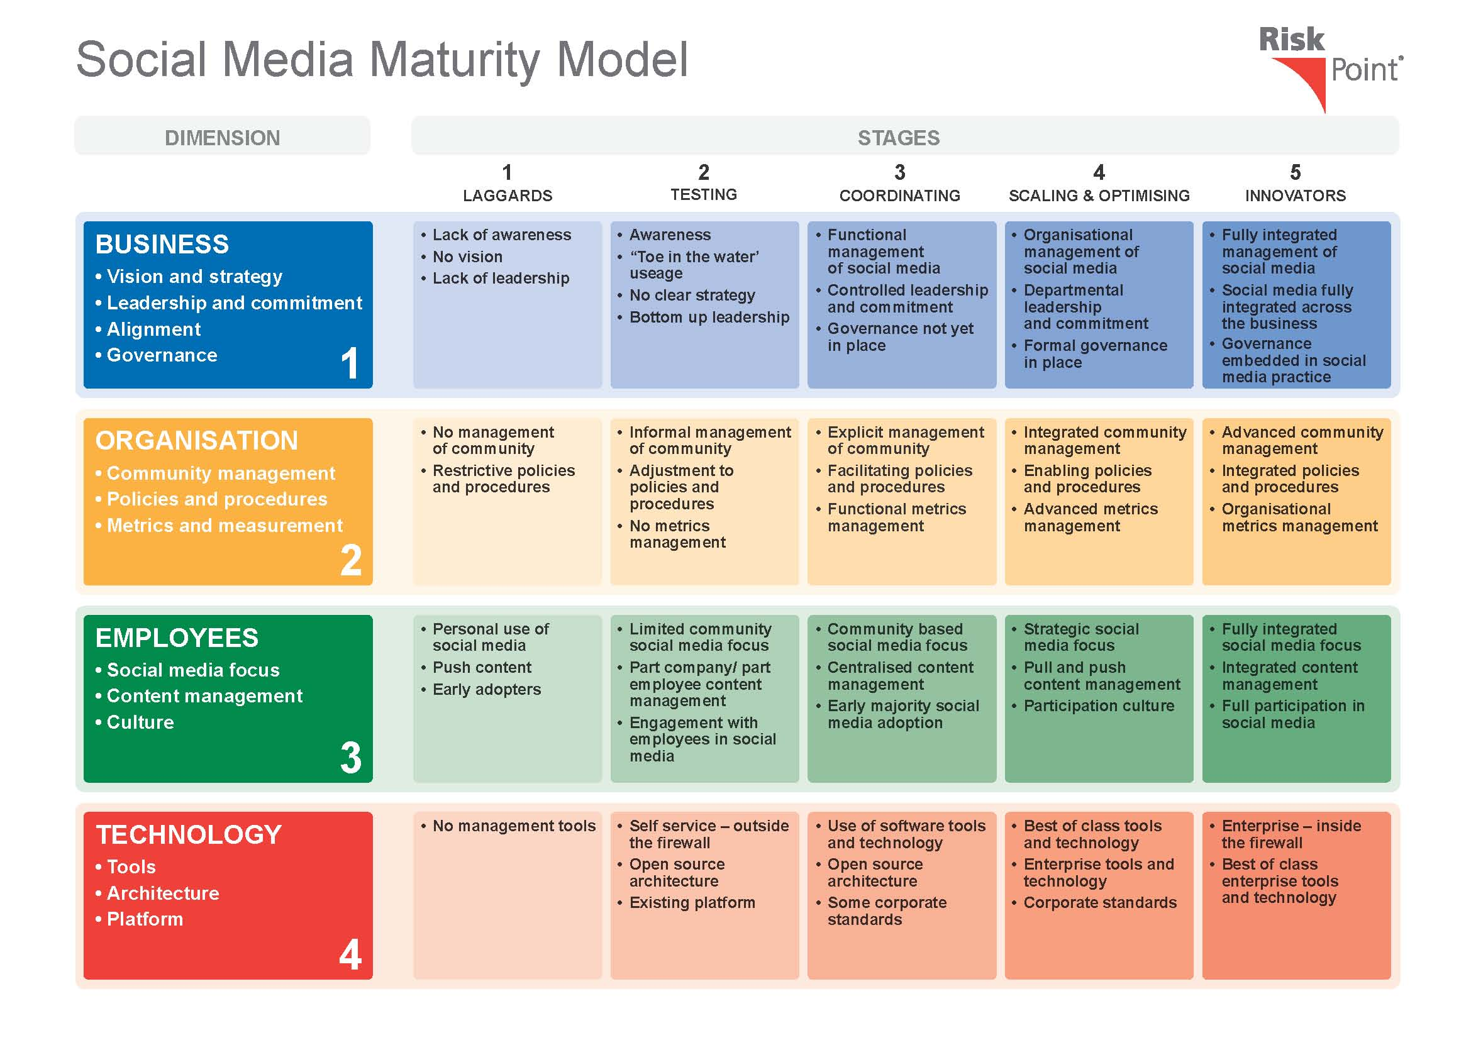

Figure 1: Maturity Model

Assessment of Singapore government Social Media maturity was based on maturity model provided by Risk Point. The model defines 5 stages of maturity level from 4 dimensions:

* Business

A point of view on the government set up its vision, takes the leadership and commitment to adopt Social Media, meanwhile to align the Social Media usage with business target by putting governance in place.

* Organisation

A point of view on how government involve in community management, and how well the policies and procedures are defined and executed.

* Employees

A point of view comes from employee’s perspective, on whether the government’s culture changes to focus on different levels of communication, and how the contents are managed.

* Technology

The evaluation on how/whether tools, platforms and related architectures are setup to support the initiative.

For better carrying out the maturity assessment, the team set up a point system to explain each level expectation of the maturity model, and standardized the evaluation by quantified scoring and maintain a level of consistency. A sample of point system is shown as below and more concrete details in appendix.

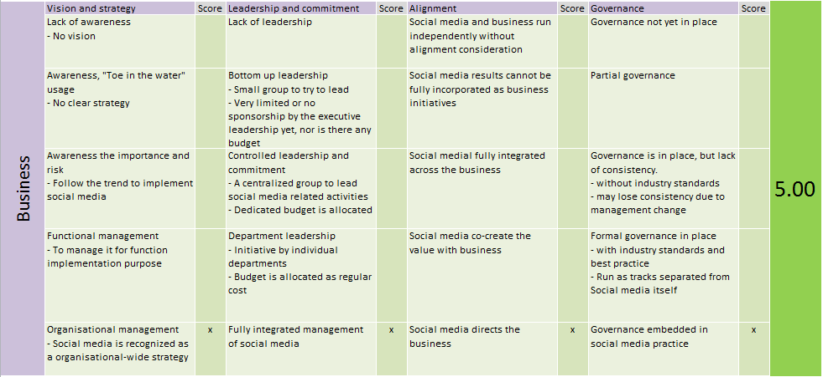

Figure 2: Point System – Business Dimension

The team designed a set of survey based on the maturity model and point system and distributed to 36 agencies. 6 responses were collected from:

* Civil Service College (CSC)
* Ministry Of Defence (MINDEF)
* Majlis Ugama Islam Singapura (MUIS)
* National Heritage Board (NHB)
* National Library Board (NLB)
* Urban Redevelopment Authority (URA)

An overview of the agencies’ maturity assessment results as below:

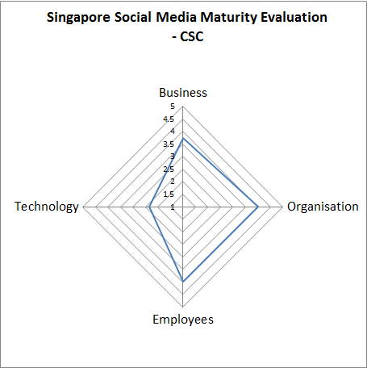 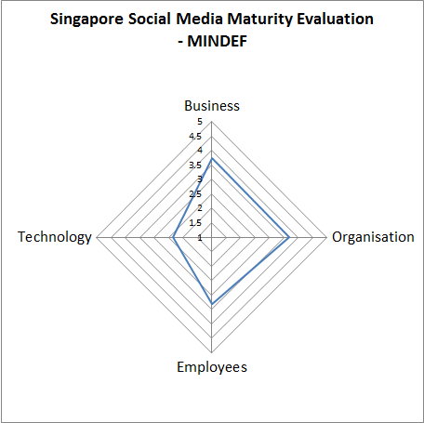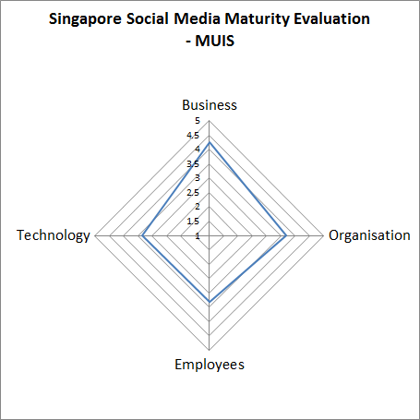

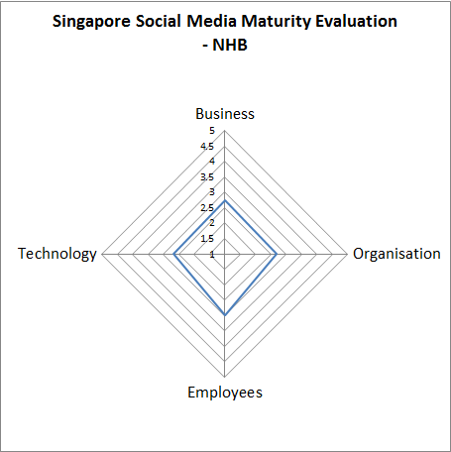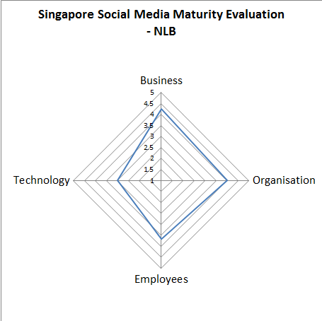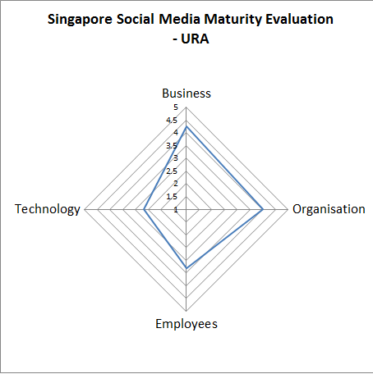

Figure 3: Agency Social Media Maturity Assessment Results

As part of the survey, we have asked the agencies about their perspective of successful Social Media and their current status. We have 3 comments from the participants.

* Government is stepping up with social media efforts because of its wide reach. Social media affords us the ability to communicate and reach out to everyone. It can be both an advantage and a disadvantage as we are able to reach out to more people, at the same time its challenging to find the resources to address the comments of every single individual we can find. **– URA**
* The government has been at the forefont of engaging the public ever since the last elections, after realising the impact and importance of engaging the Singaporean people, whom their existence depends on. Their efforts could be lauded though they may have started a bit slow in the beginning. More policies are being discussed and feedback gathered from these social media sites, but some still remain closed to public consultation. A good development overall. **– MUIS**
* The government has put in a lot of focus and effort to learn and improve how we can leverage on social media to reach out and have more impact in engaging the public. It is a learning process and continual improvements need to be made to engage the public as social media also has a component of maturity that ties with the contents. **- NLB**

### Analysis of agency survey

1. Most of the government agencies are in the same stage of maturity, which presents as similar pattern from evaluation results.
2. Government agencies are strong in Business, Organisation and Employees dimensions, in terms of vision setup, governance, policy and procedures, and staff capability.
   * Basically all of the participants agree the importance of Social Media in the ability to communicate and reach out to public, thus a high vision and level of leadership commitment were in place for 2 or more years.
   * With most of the declarations from agencies, the policies and procedures were setup and followed through.
   * In terms of the staff preparation, training was carried by most of the agencies, but yet with difficulties like lack of manpower, lack of continual training and the quality.
3. Many of the government agencies are in low adoption of technology to support the Social Media initiative, which may result in low efficiency and slow responses.

#### Public Survey

This survey gathers the public views to analysis the current status of government adopting social media. It will help to analyze the gap between government agencies’ views and public view, and also the public expectation. This survey will help to verify the result of the agency survey.

* Result of the Survey

The Team distributed this survey to 30 people who is actively involved in social media for many years. 27 responses have collected. Based on data collected, it gives bellow points, and the details are addressed in Appendix [XXX]:

* The rate of public engagement is low, the possible reasons are:
  + Public is not aware of government’s adoption on social media
  + Government do not have enough resource to engagement more public in at current stage
* Public is overall satisfied with the reply from government agency
* 75% of the respondents rate the agency officer’s communication skill is good
* 60% -70% of the respondents think the information replied is concrete and consistent
  + Government trained the staff to deal with social media, but the resource is not enough to handle hug mount of information
  + Government established processes, policies, guidelines, code ethic etc. to post/reply content. But as social media is still in earlier stage in government, it requires continual improvement.
* Government agency response slowly and does not actively engage in communication
  + To reduce the risk of social media, government agency need to follow process, policies, code ethic strictly, it is time consuming
  + There is no enough trained officer to handle social media
  + Lack of technology support to reduce some analysis time

#### Gap Analysis

Comparing with the result of agency survey, the public survey also shows that government has trained the employees, established processes, policies, guideline to deal with social media. The level of the Business, Organization and Employees are high from government agencies’ self-appraisal, however, the public survey shows that public engagement is low, government response is slow and government also not actively engaged in. Does this imply that government agencies do not have a proper measurement model currently? Without the measurement model, it is difficult to assess whether social media achieves its goal, and it is also difficult to do continual improvement, as it cannot know whether it is good enough or not.

## Social engagement study and metrics

Social media channels provide additional avenues for receiving feedback. Singapore government has made big advances in adopting social media platform.  The Government Social Media Directory was launched in 2011 to provide a convenient platform for the public to discover and access social media initiatives managed by public sector agencies.  In order to sustain the success, different metrics should be in place and agencies should be monitoring them consistently to track the progress and the performance of the engaged platform.

Analysis of this social data is critical not just for agency communication offices but also for program managers at every level of the organizations.  Social media in government increasingly requires accurate, targeted performance analysis to ensure they are taking full advantage of these tools to deliver better service and engagement to citizens.  It provides a framework for agencies to measure the value and impact of social media in addressing agency mission and program goals.

As an example, the American government has defined basic metrics that agencies can analyse through all platforms; organized into seven main categories:

* Breadth
  + Community Size
  + Community Growth
* Depth
  + Conversions
  + Viewing
* Direct Engagement
  + Engagement Volume
  + Engagement Responsiveness
* Loyalty
  + Return Community
* Customer Experience
  + Sentiment
  + Indicators
  + Survey Feedback
* Campaigns
* Strategic Outcomes

It has come to our attention that, currently there are no publicly published information (websites or white paper) available in Singapore regarding how the progress has been measured for government social media engagement.

#### Analysis of government social media engagement (Facebook)

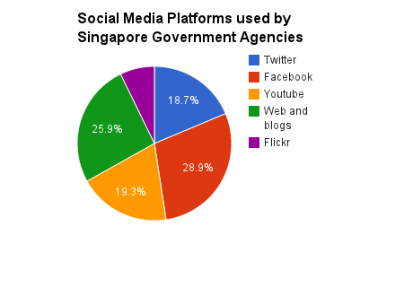

*Figure: Social Media Platforms used by Singapore Government Agencies*

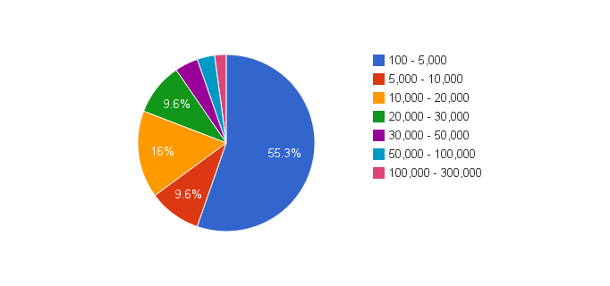

*Figure: Current active fans on Facebook (community growth)*

According to the Government Social Media Directory, Facebook is the most engaged platform used by the Singapore Government Agencies.  In this case study, we have performed analysis using some of the above metric on the government agencies’ Facebook pages. According to the analysis approximately there are 107 Facebook pages created by government agencies.

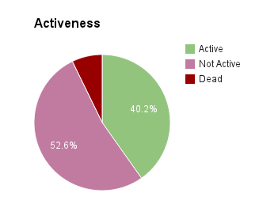

*Figure: Current active engagement on the Facebook pages*

First, we have measured the activeness of each agency's pages.  Activeness is measured by how frequently the agency is publishing new quality content on daily basis.  Among them 40.2% is actively posting new contents and shared information with the public.  However, 52.6% of pages are not adding new posts and contents actively (daily).  In the social media context consumers are now driving interactions online, they expect transparency of the government policies and would like to participate in government matters and with this figure the agencies has to improve the way they share and interact with public.  Sadly, 7.2% has stopped publishing contents on the Facebook platform.

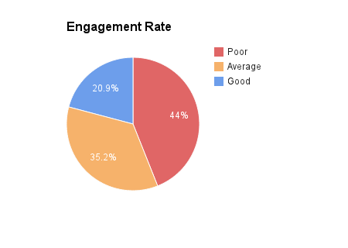

*Figure: Engage volume by agencies’ pages*

Apart from agencies’ pages those are no longer participating in Facebook (we were left with 94 pages), we have measured the engagement volume that tells the frequency and effectiveness of your engagements.  Our analysis shows that out of 94 pages, only 20.9% engage effectively while 35.2% are not taking full advantage of social media.  The rest has received poor engagement rating and there occupy 44%.

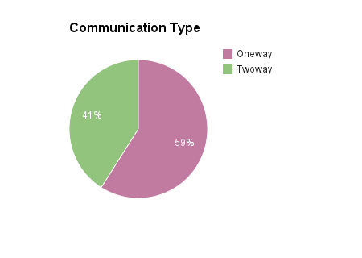

*Figure: Different communication type engaged by agencies’ pages*

Next we looked at what is the communication mode between agencies and the citizens.  The majority of agencies’ pages are having only one way communication with their fans.  That means they publish contents through social media but they fail to listen and collaborate with the community.  On the other hand 41% of the pages are open for commenting and invite community to have conversation with the agency, realizing that one way communication does not improve the presence on the social media.  According to the detail analysis on the Facebook platform, there are agencies which are not open and not inviting people to engage in dialogue and having one way communication which does not improve the presence on the social media.

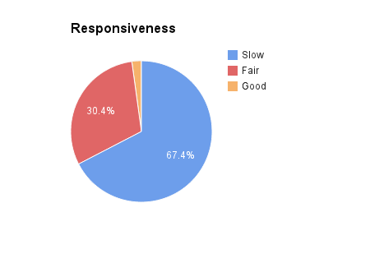

*Figure: Engagement responsiveness of agencies’ pages*

Finally, we analyse the responsiveness of the pages. According to our analysis, only 2.2% responds quickly for the question and comments posted by community. 30.4% has average response rate and 67.4%  has very slow response rate and they have to be more interactive with their fans.

For this we used two different tools and the tools calculate base on the following formulas:

[http://likealyzer.com](http://likealyzer.com/)

www.socialbakers.com/

# Comparison with other governments

It is quite obvious that the governments of Australia, Britain and the United States, believe their citizens are entitled to information. They see the release of information both as a tool of accountability and as a resource to support innovation and create value. They recognize the risks and are attempting to manage them through guidelines, training, and culture-building, while trusting that public servants have a “feel” for how to react in real time.  

In Canada, the federal government is using the web to consult with citizens to learn if they agree with a plan to introduce random breathalyzer tests to deter drunk driving. Some provinces have designed policy through full blown online consultation such as B.C.’s “Conversation on Health” and Ontario’s “Electoral Reform” that involve face- to- face meetings, blogs and online forums. New Zealand used blogs and wikis to help write their new Police Act.

# Recommendation

The public sector needs organizational change, developing a culture of trust and openness that will allow public servants to take advantage of the benefits that social media offer. Organizational and cultural change is required in order to modernize government so it can benefit from new media. A culture of collaboration and trust is needed.

# Appendix

### Survey Questionnaire

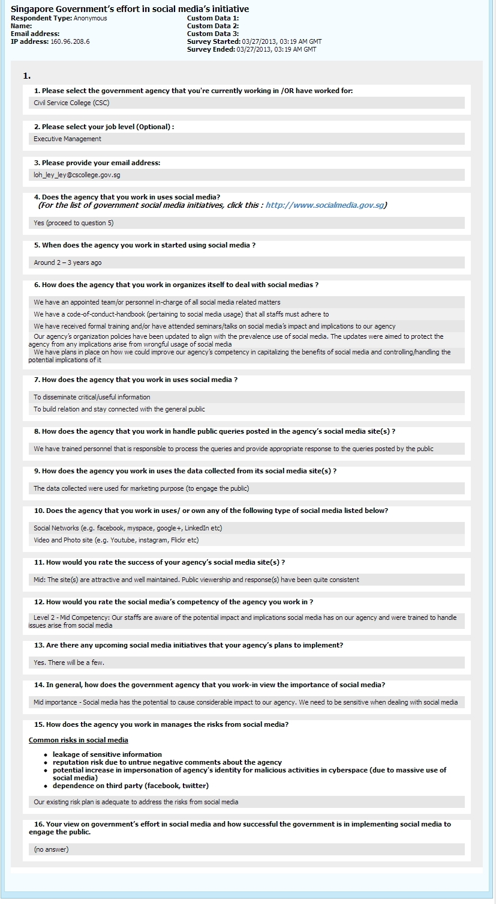

Figure 1: Agency Survey Questionnaire - CSC

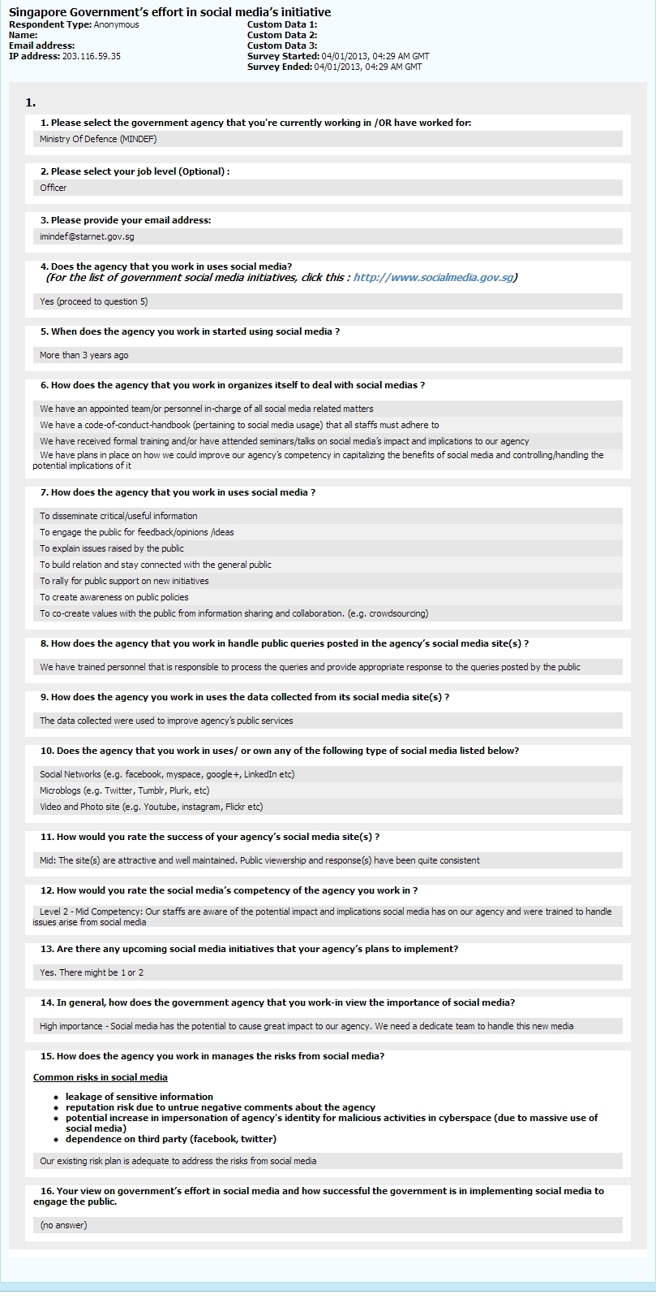

Figure 2: Agency Survey Questionnaire - MINDEF

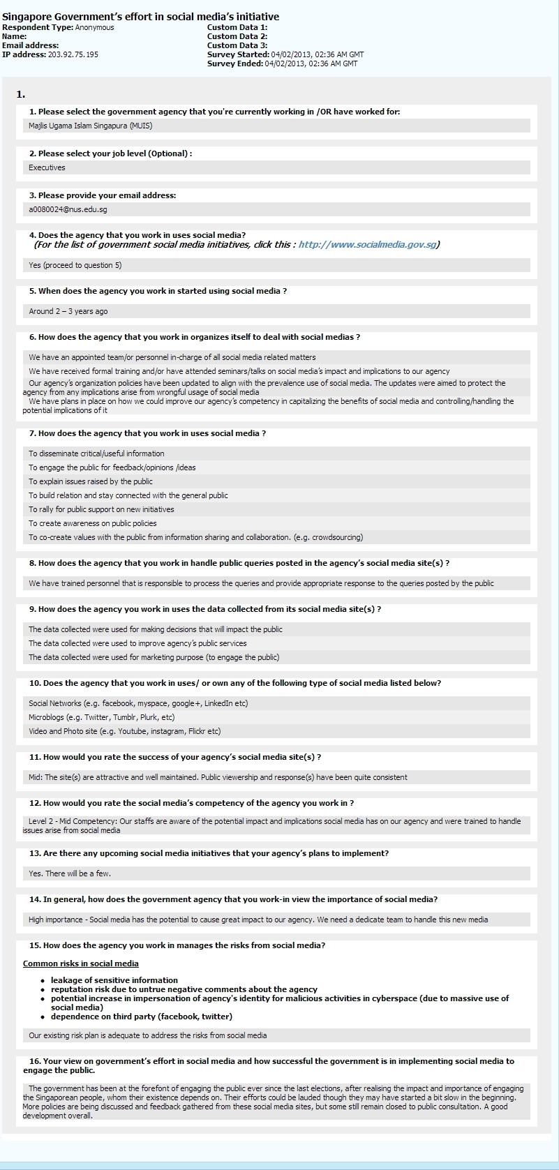

Figure 1: Agency Survey Questionnaire - MUIS

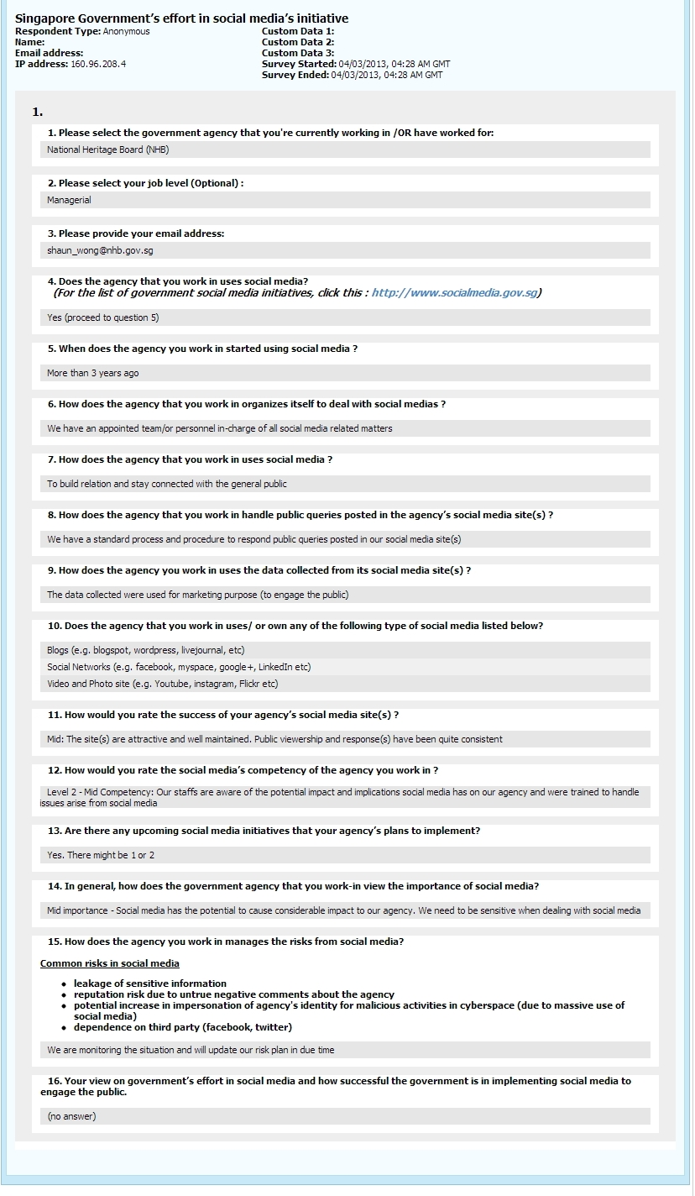

Figure 1: Agency Survey Questionnaire - NHS

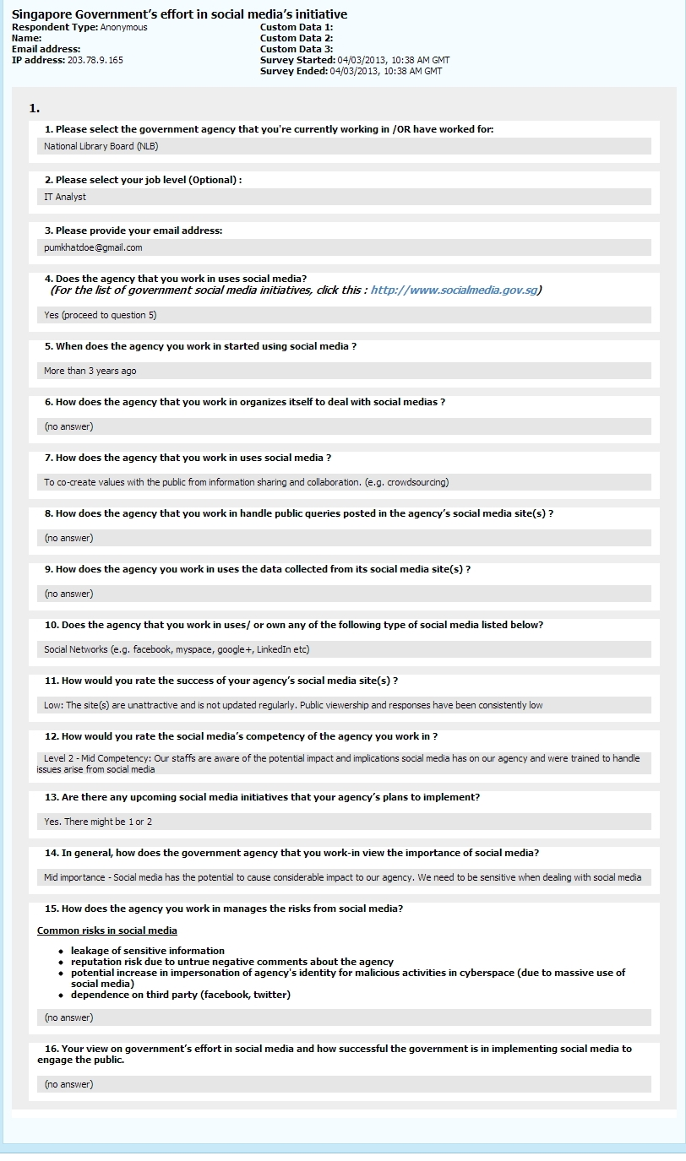

Figure 1: Agency Survey Questionnaire - NLB

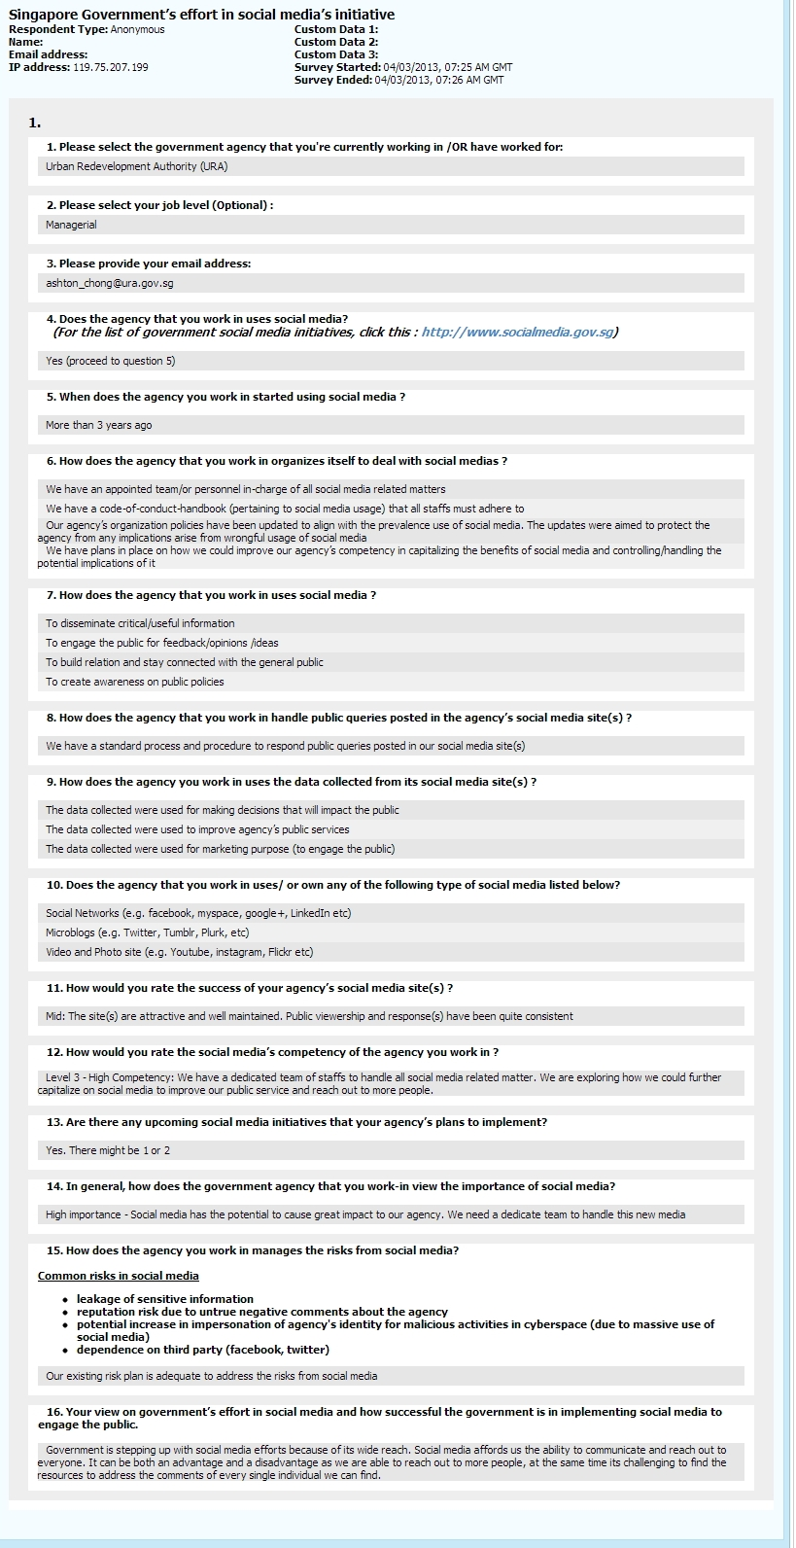

Figure 1: Agency Survey Questionnaire - URA

### Evaluation Point System

 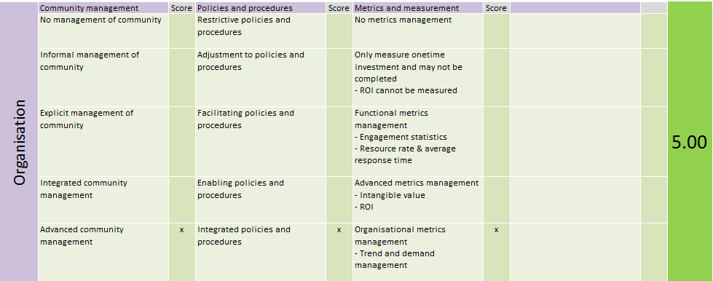 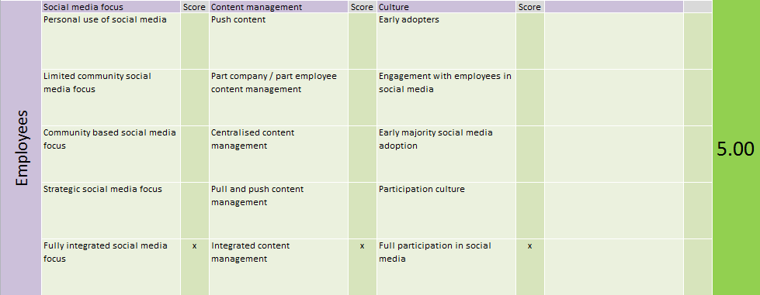 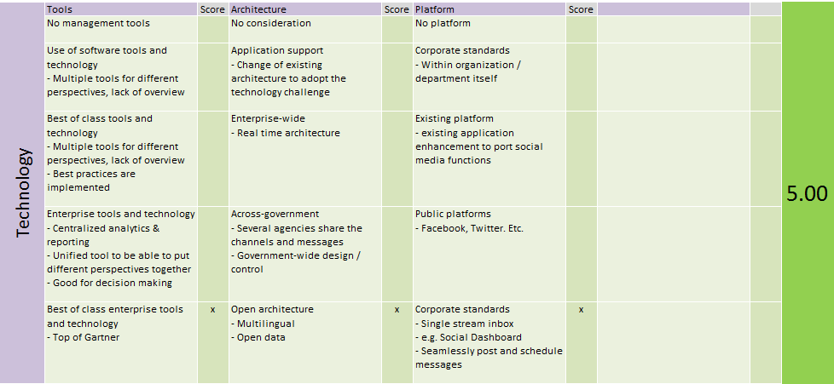

Figure 1: Point System

### Public Survey Analysis

#### Engagement of public

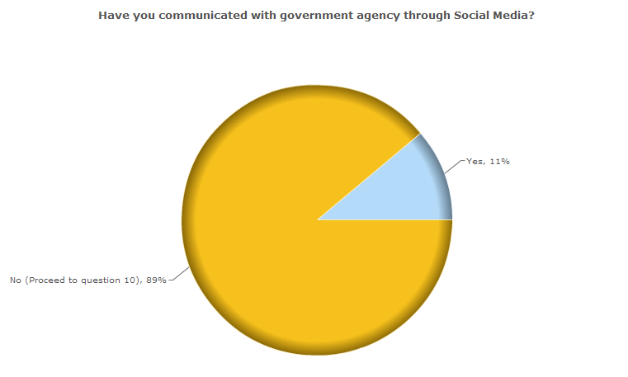

**Fact:**

89% of the respondents are not participation in government social media directly

**Analysis:**

According to the data collected, the engagement is low currently; the reason can be described in two sides. One is public may not know the channel or they are not willing to communicate through this channel due to some concerns such as privacy. On the other side, even government agencies launched a lot of social media channels (almost 700 total) in recent 3 years, and also put much effort in staff training, establishing the process, defining guideline, governance and structure changes to embrace social media, but they are still not playing so active to play two way communication to engage more people. The answer from **URA** may address this.

* Government is stepping up with social media efforts because of its wide reach. Social media affords us the ability to communicate and reach out to everyone. It can be both an advantage and a disadvantage as we are able to reach out to more people***, at the same time its challenging to find the resources to address the comments of every single individual we can find***. **– URA**

#### Public Satisfaction

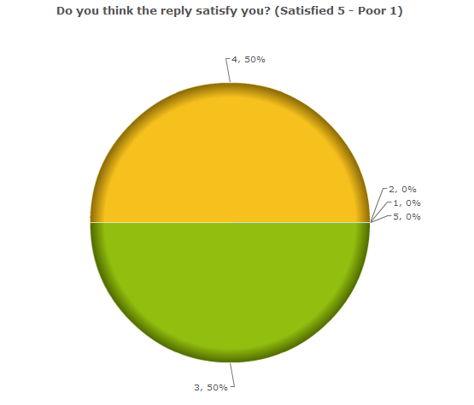

**Fact**:

50% of respondents are quite satisfied with the answer from government, and others are normal satisfied.

**Analysis**:

There are kinds of questions including some odd questions being asked by public on social media, it requires very skilled speakers on behalf of government to reply public; otherwise it may disappoint public or cause reputation issues. According to the satisfaction status, it indicates that government did not bad in social media even in current stage. Government has training, processes, guidelines to ensure that social media can serve public properly.

#### Communication Skills

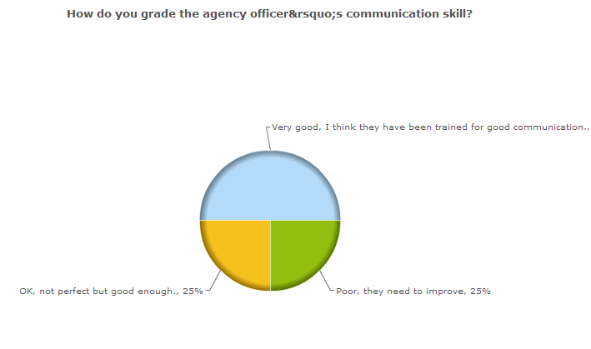

**Fact**:

75% of the public think that government agency officer’s communication skill is good or very good, 25% think they need to improve.

**Analysis:**

Communication skill is the key capability of utilizing social media. As describe in ‘Public Satisfaction’, government already did some training to embrace social media, to make it can serve public properly.

#### Quality of contents

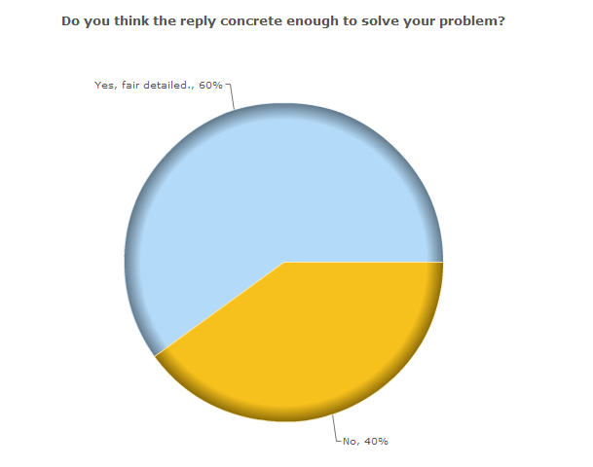 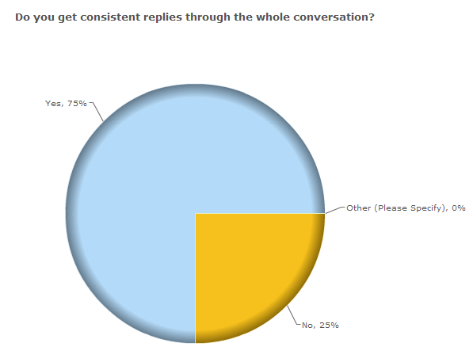

**Fact:**

60% of the respondents think government post is concreted and 75% think they keep consistent through whole conversation.

**Analysis:**

According to the result, the quality of the post is not bad, but not very good. We can say ‘Concrete’ reply is the communication skill, but to keep conversation consistent, the quality control must be in place.

Recall the survey result conducted among government agencies, the process, guidelines and governance are in place to maintain the quality. But social media is a totally new communication way between government agencies and public, some of the experience from traditional way may not take effect in social media.

Even all the processes, guidelines are in place, but based on the response of public, it requires continual improvement. Also as NLB commented in the survey, it is a learning process and continual improvements.

* The government has put in a lot of focus and effort to learn and improve how we can leverage on social media to reach out and have more impact in engaging the public. ***It is a learning process and continual improvements*** need to be made to engage the public as social media also has a component of maturity that ties with the contents. **- NLB**

#### Government Response

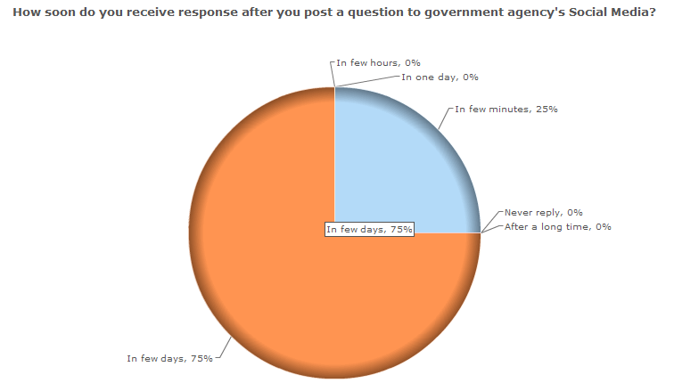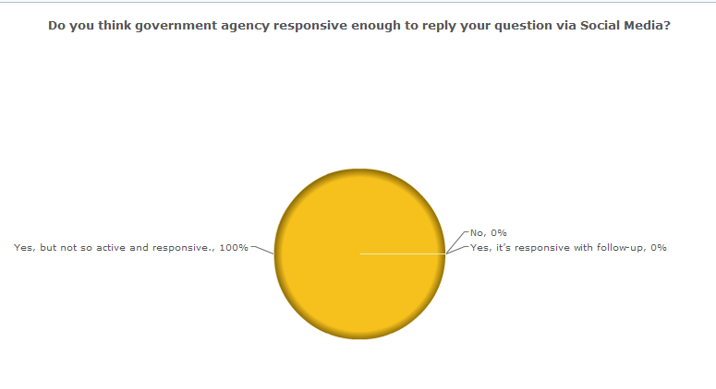

**Fact:**

Government agency takes long time to answer public, it is not interactive actively.

**Analysis:**

In traditional, government is slow and steady, even government already did some organization structure changes, but for each post, it may require layers of approval, multiple edits & re-edits to ensure that the contents are accurate with adequate information. As the ***URA*** commented, government agencies also do not have enough resource to handle social media, thus government will not take part in some of the discussion, so it behaves ‘not active’.

It also due to government agency lack of technology support, such as there should be some tool to categorize amount of public information, and reply in one group for similar topic.

Also due to the resource Constraint, Singapore government now is more on information dissemination and listen public idea and concerns.

#### Public Expectation

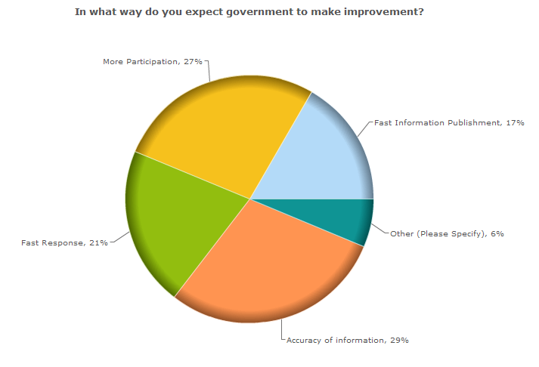

**Conclusion:**

Although government already put much effort in social media, but it has some gap between public expected. Public expects government to response fast, play more active and post information more accurate.

Based on survey and analysis, it may not possible to reach public expectation in current stage, such as the resource Constraint, risk management. But government can continually improve to archive two way communications, to play more active, hence government can meet the vision: ‘To be a Collaborative Government that Co-creates and Connects with Our People’

# Bibliography

Blackbox Research Pte Ltd, May 2012. *Smart Phones in Singapore: A Whilte Paper Release,* Singapore: Blackbox Research Pte Ltd.

Chapman, C., 2009. *The History and Evolution of Social Media.* [Online]   
Available at: http://www.webdesignerdepot.com/2009/10/the-history-and-evolution-of-social-media/  
[Accessed 30 3 2013].